**4×4 Matrix Keypad Interfacing**

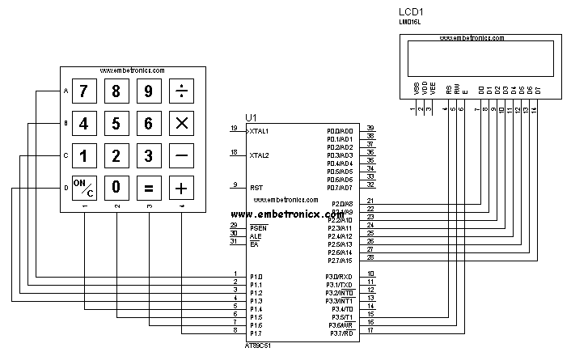

#include<reg51.h>

#define lcd P2

sbit rs=P3^5;

sbit rw=P3^6;

sbit en=P3^7;

sbit r1=P1^0;

sbit r2=P1^1;

sbit r3=P1^2;

sbit r4=P1^3;

sbit c1=P1^4;

sbit c2=P1^5;

sbit c3=P1^6;

sbit c4=P1^7;

void lcd_init();

void cmd(unsigned char );

void dat(unsigned char );

lcd_string(unsigned char *);

void delay(unsigned int );

void keypad(void);

void main()

{

lcd_init();

while(1) {

cmd(0x80);

lcd_string("Enter the key:");

cmd(0xc7);

keypad();

}

}

void keypad()

{

c1=c2=c3=c4=1;

r1=0;r2=1;r3=1;r4=1;

if(c1==0){

while(c1==0);

dat('7');

} else if(c2==0) {

while(c2==0);

dat('8');

} else if(c3==0) {

while(c3==0);

dat('9');

} else if(c4==0) {

while(c4==0);

dat('/');

}

r1=1;r2=0;r3=1;r4=1;

if(c1==0){

while(c1==0);

dat('4');

} else if(c2==0) {

while(c2==0);

dat('5');

} else if(c3==0) {

while(c3==0);

dat('6');

} else if(c4==0) {

while(c4==0);

dat('*');

}

r1=1;r2=1;r3=0;r4=1;

if(c1==0){

while(c1==0);

dat('1');

} else if(c2==0) {

while(c2==0);

dat('2');

} else if(c3==0) {

while(c3==0);

dat('3');

} else if(c4==0) {

while(c4==0);

dat('-');

}

r1=1;r2=1;r3=1;r4=0;

if(c1==0){

while(c1==0);

cmd(0x01);

} else if(c2==0) {

while(c2==0);

dat('0');

} else if(c3==0) {

while(c3==0);

dat('=');

} else if(c4==0) {

while(c4==0);

dat('+');

}

}

void lcd_init()

{

cmd(0x38);

cmd(0x0e);

cmd(0x06);

cmd(0x01);

}

void cmd(unsigned char x)

{

lcd=x;

rs=0;

rw=0;

en=1;

delay(1000);

en=0;

}

void dat(unsigned char y)

{

lcd=y;

rs=1;

rw=0;

en=1;

delay(1000);

en=0;

}

lcd_string(unsigned char *s)

{

while(*s)

dat(*s++);

}

void delay(unsigned int z)

{

unsigned int i;

for(i=0;i<=z;i++);

}